Jenkins

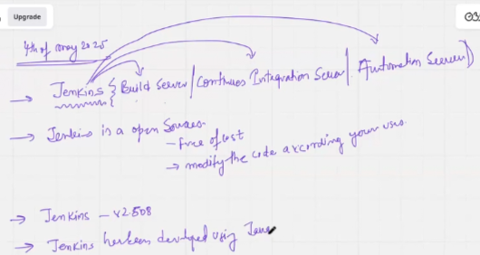

Competition

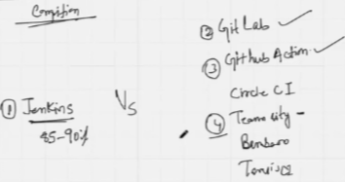

Why do I use Jenkins?

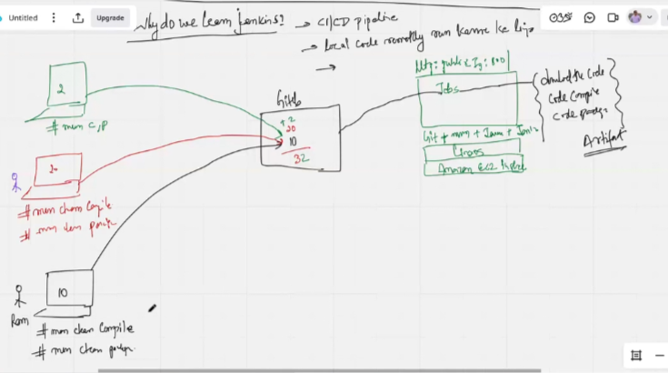

Why do I use Jenkins(with example)

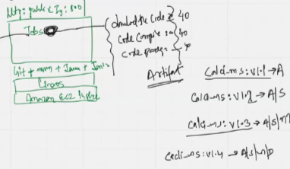

Four different developers are working on a project. Coder A added Addition code to jenkins, Coder B added Subtraction code to jenkins, Coder C added Multiply code to jenkins, Coder D added Division code to jenkins. Adding 10+10+10+10 every time individually. By doing it, jenkins is **continually integrating**

Steps to work with Jenkins

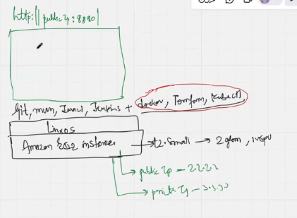

Goto EC2 >> name=JenkinsMasterMay2025 >> Amazon Linux 2023 >> t2.micro/t2.small/t2.medium >> create a key pair with .ppk extension >> Launch instance

Then

Goto Security group >> Edit inbound rules >> SSH >> My IP >> Port 22

Goto Security group >> Edit inbound rules >> Custom TCP >> Anywhere IPv4 >> Port 8080

Then

Download putty >> Select ip >> port >> ssh >> add private key in Authentication 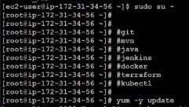

Then

Goto https://www.github.com/satyam88/greentea/ami and follow below steps

Then

Jenkins configuration is required

Then

Public ip:8080 >> load the jenkins password >> Install suggested plugins >> Point A >> Getting started >> username=jenkinsadmin >> same password >> Full name >> Email - [jenkinsadmin@gmail.com](mailto:jenkinsadmin@gmail.com) >> save and continue >> Instance configuration >> Jenkins URL: <http://publicip:8080/> >> Save and finish >> Setup is ready

**A: Goto plugins index**

Plugins for jenkins are analogous to applications on playstore. Apps from playstore increase capability of mobile, and similarly plugins are required to increase capability in jenkins.

In Jenkins installation on linux server, default plugins are configured that are below par. We can work with them under capacity reservations. To work with AWS and other Cloud, pre-configured Jenkins will also need further plugins.

Goto Jenkins >> Manage Jenkins >> Plugins >> Available plugins >> AWS credentials, pipeline, kubernetes, kubernetes pipeline, kubernetes CLI, kubernetes credentials >> Install >> Restart jenkin to put above into effect >> Login to jenkins

>> We can also restart jenkins from command line and then login:

* Service jenkins status
* Service jenkins stop
* Status show stopped
* Service jenkins start
* Status shows started

How is Jenkins an automation server?

Create a project to run a script every minute

Goto New item >> demofirstjob >> freestyle project >> OK >> Build steps >> Execute shell below >> Trigger >> Build periodically >> */1 * * * * >> Save ……… displays error for permission

* #!/bin/bash
* Ping -c 5 [www.google.com](http://www.google.com) >> /tmp/google.txt

>> Point B

>> Test the results from jenkins

**B: check jenkins in linux as userid, which shows for (ls -ld) that the files are allowed access by root user only. Add jenkins in visudo like** : 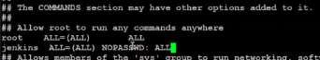 **then do CTRL+s, CTRL+x**

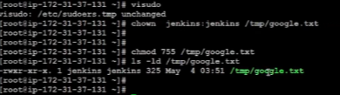

Working with tools in jenkins

Goto Jenkins >> Tools >> Add JDK >> name=java_21 >> path >> point C >> Add path - **/usr/lib/jvm/java-21-amazon-corretto.x86_64/**

Git installations >> name=git >> path to git >> point D - **/usr/bin/git**

Maven installations >> name=mvn_3.9.9 >> MAVEN_HOME >> point E - **/opt/apache-maven-3.9.9**

SAVE

**C:in linux do**

* Java –version
* Which java
* Readlink -f /usr/bin/java
* Cd

**D: in linux do**

* Which git

**E: in linux do**

* Echo $M2_HOME

PROJECT

